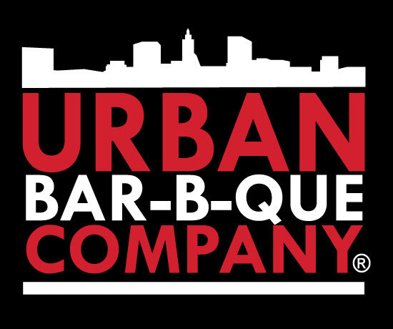

Please come out and support Potomac Heights Volunteer Fire Department & Rescue Squad by purchasing a delicious meal! 20% of all sales between 4pm-9pm will be donated to our department.

Tuesday, September 25, 2018
4pm - 9pm
13 Shining Willow Way, La Plata, MD 20646

Thank you for your support!

